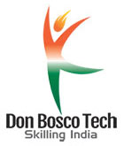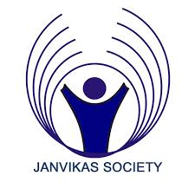**Guest Lecture Report**

**Domain – Assistant Electrician**

On 15th March 2021, Don Bosco Tech Palda, Indore Organised a Guest Lecture for the Assistant Electrical trainees. The speaker was Mr. Rahul Sharma who is working as an Head Technician in Hitachi Group of Pvt. Ltd. The lecture was started at 11 am and session was for 2 hours and the topic was **Air Conditioner**.

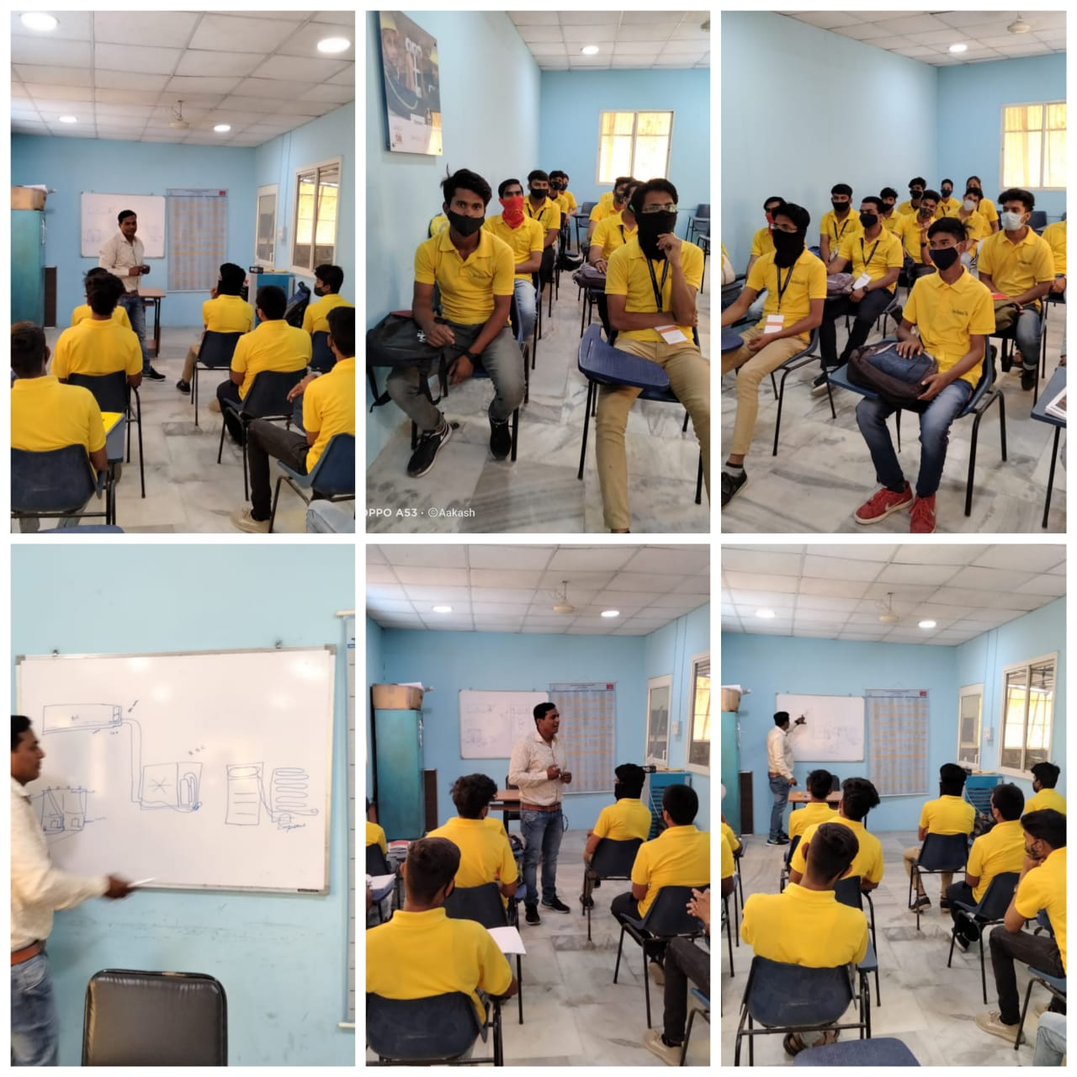He explained to the trainees that Air conditioning units or the air conditioners are used in everyday life to cool the air around us. They are a very common consumer electronic device. Inside the air conditioner, refrigeration of some special gases takes place to give out cool air, much like in refrigerators. The [air](http://www.collegelib.com/t-air-pollution-seminar-topic-abstract-seminar-report.html) condition uses the simple principle that while changing from liquid state to gaseous state, the substance gives out heat. To send out, cold air, the air conditioner has special substance which is used as a refrigerant. This substance is evaporated and condensed continuously to give out cool air. This process takes place in the closed condition inside the unit.

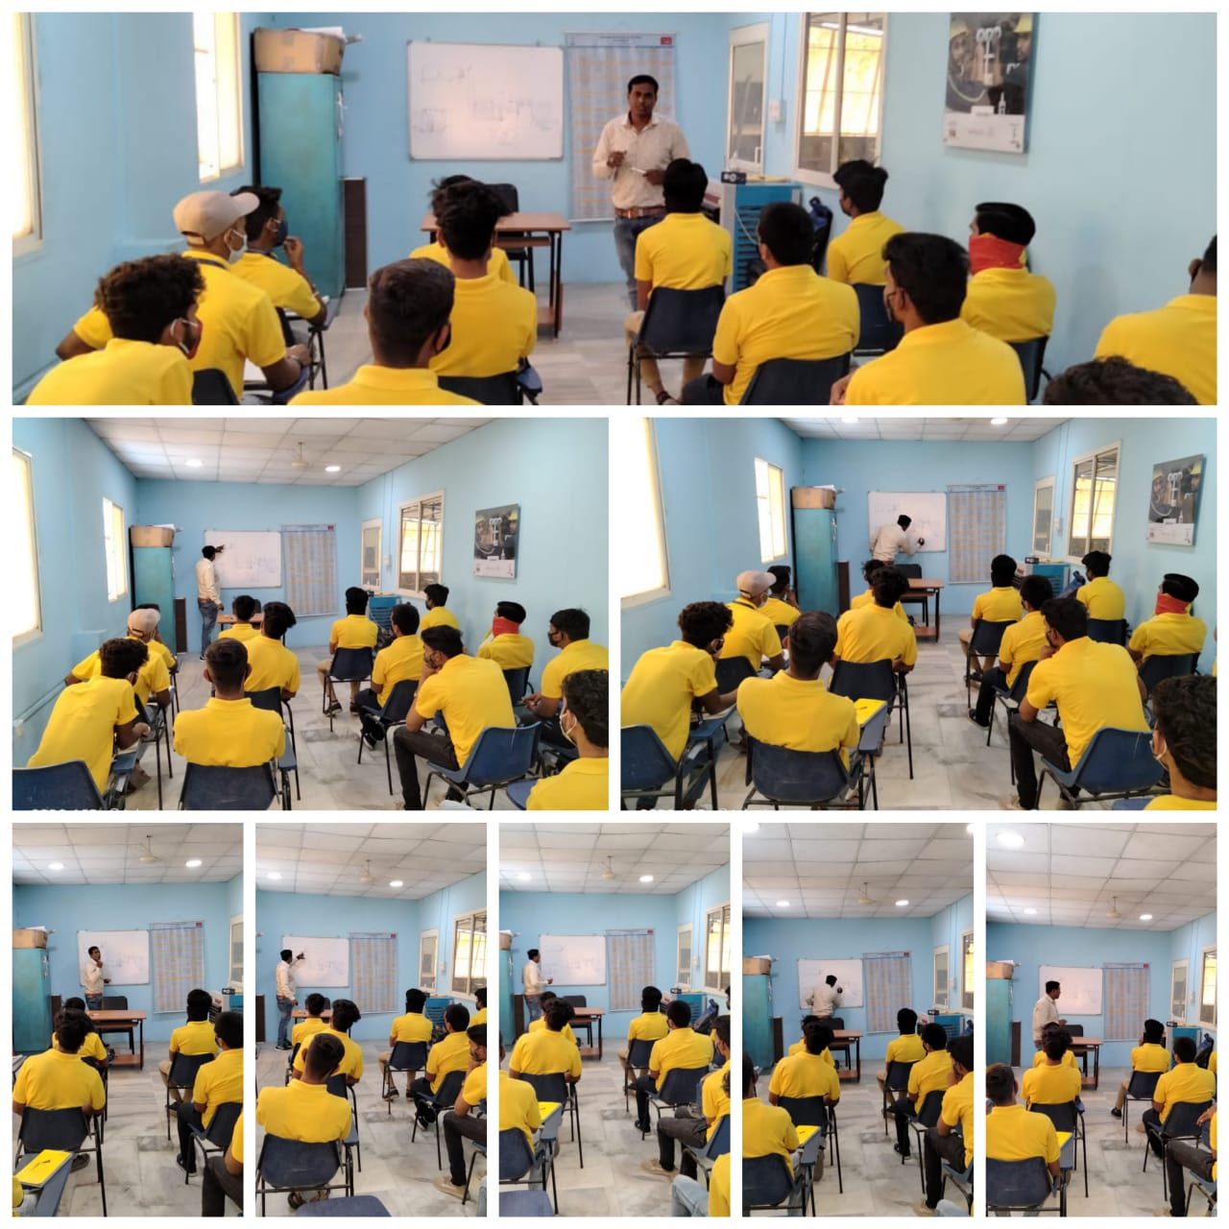There is a proper mechanism to pass the heat generated during this process out of the machine from the other end. In centralized air conditioners, there is a duct system to channel hot air away and keep the system from heating inside. The fan is also provided for the same reason. A compressor is also fitted inside the machine to convert the gas back to liquid. The compressor basically creates high pressure and converts the gas back to liquid so that the process continues and the temperature remains controlled. Thus, the refrigerant constantly maintains the indoor temperature and the inside temperature of the system is also controlled.

It was a good learning experience for the students. They had many questions and the speaker made the students to understand well with his interventions.