Batch Inauguration, Students Kit Distribution & Parents Meeting
Report
Don Bosco Tech Vejendla
Event: Batch Inauguration, Students Kit Distribution & Parents meeting
Domain: Solar PV Installer [Suryamitra] & Drone Manufacturing & Assembly Technician
Date: 11-05-2026
Guests:
Sr. Mary Kumari Director Of SSS JMJ & Centre Head of DB – Tech Vejendla
Sr. Anne Louice Retired Teacher

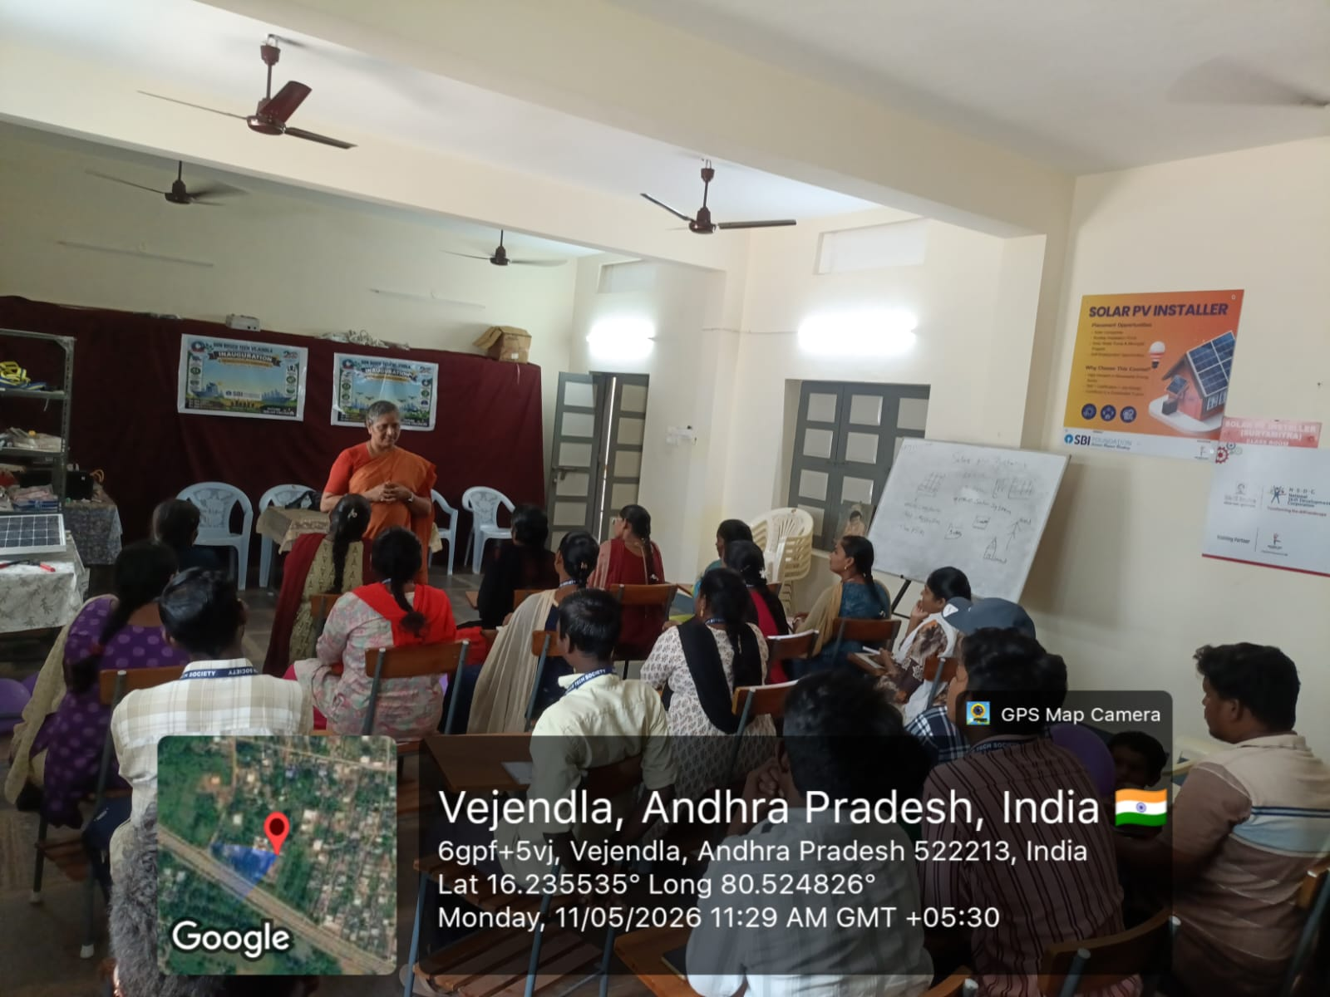

Report

Today, [11-05-2026 Monday] DB Tech Vejendla successfully organized the Batch Inauguration, Student Kit Distribution, and Parents’ Meeting for the Solar PV Installer and Drone Manufacturing & Assembly Technician domains. The event marked an important beginning for the new batch of trainees and was conducted with great enthusiasm and active participation from trainees, parents, and staff members.

The program commenced with a warm welcome to the Chief Guests, Sr. Mary Kumari, Director of SSS JMJ and Centre Head of DB Tech Vejendla, along with Sr. Anne Louice. Their gracious presence added significance to the occasion and encouraged both trainees and parents.
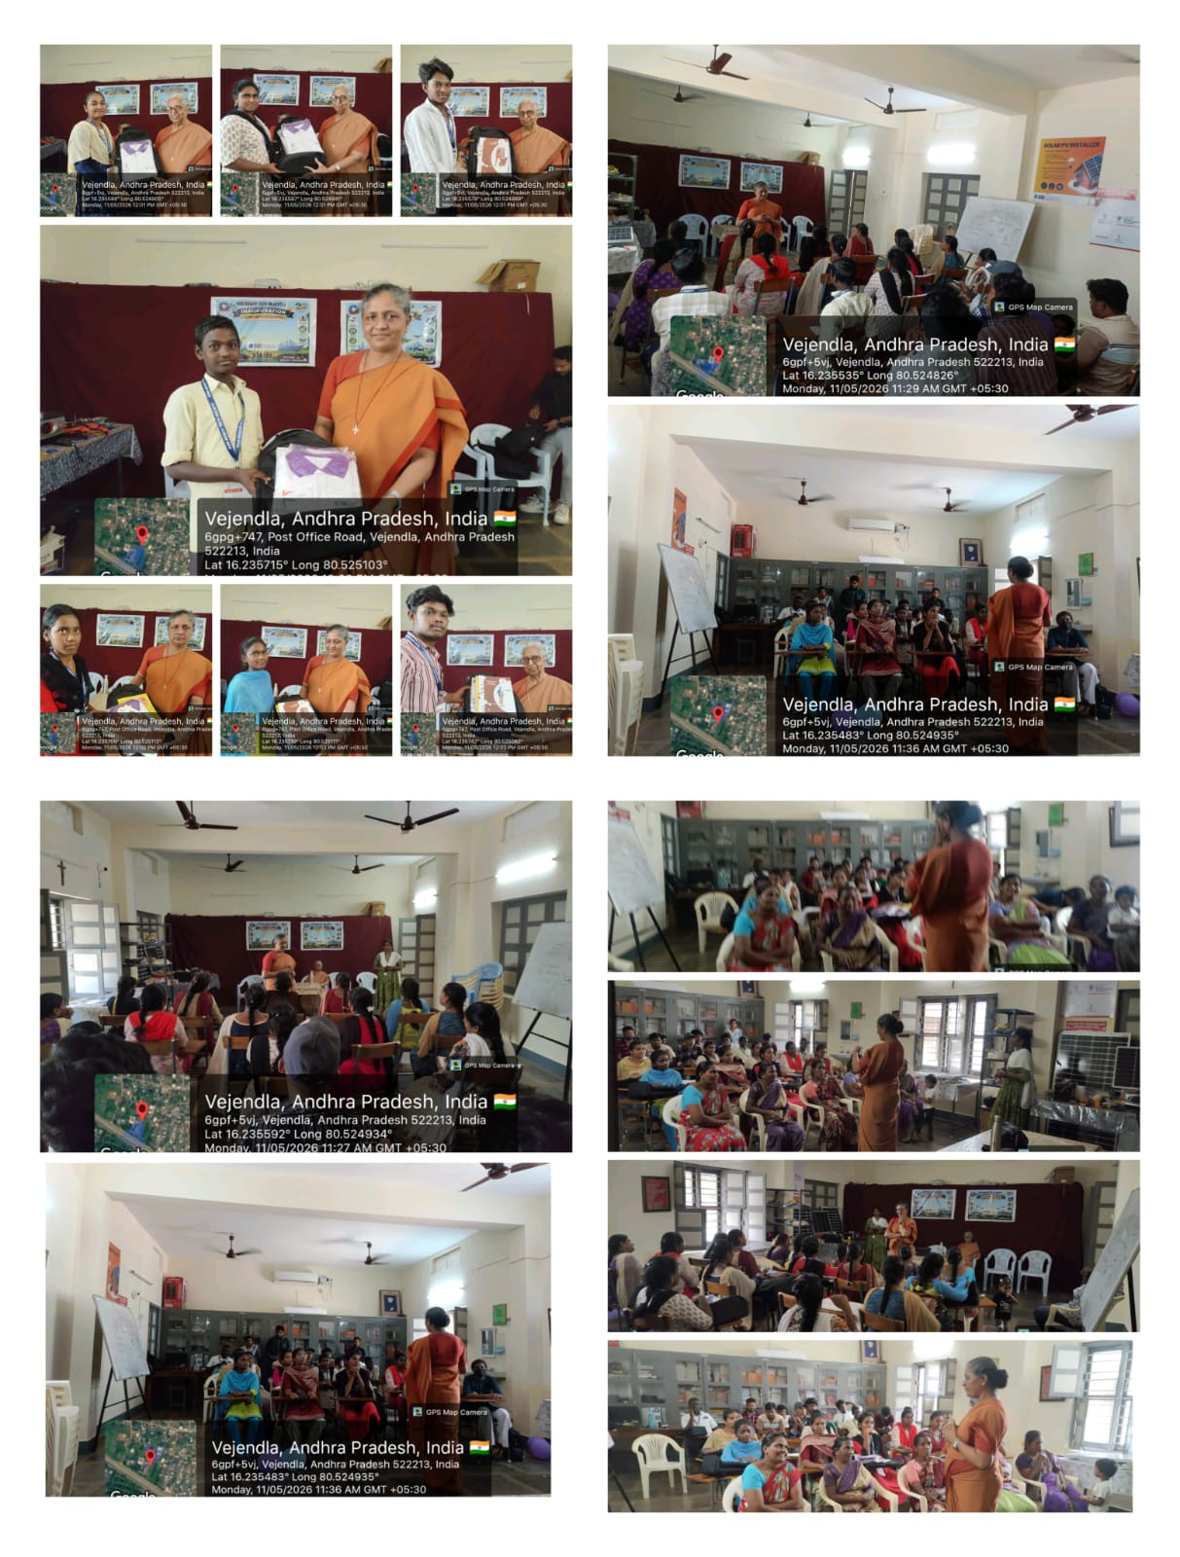

As part of the inauguration ceremony, the new batches for the Solar PV Installer and Drone Manufacturing & Assembly Technician domains were officially launched. Student kits were distributed to the trainees to support their learning journey and skill development training.
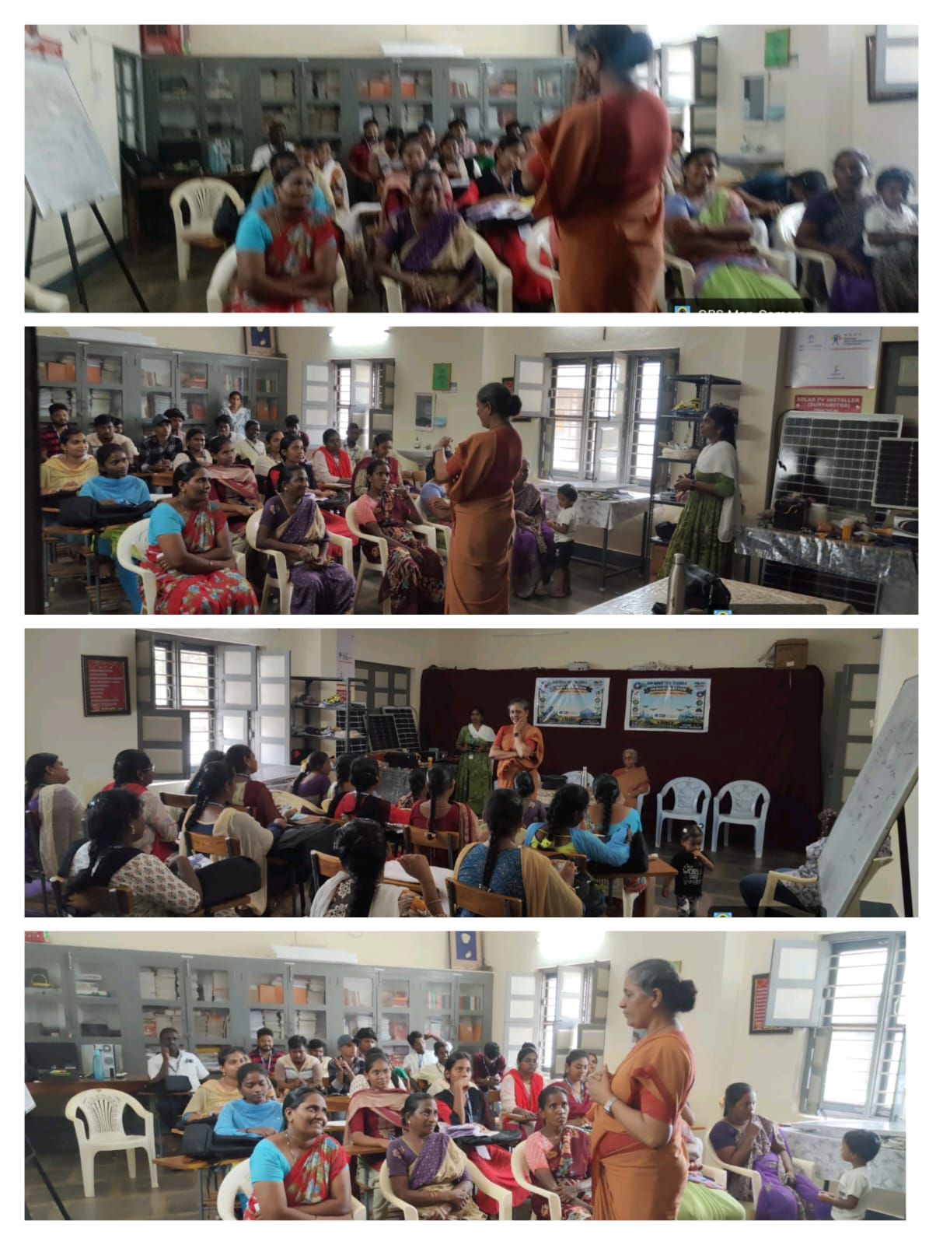

During the Parents’ Meeting, the objectives of the training program, placement opportunities, discipline, attendance, and the importance of skill-based education were explained to the parents and trainees. The session helped parents gain a better understanding of the career opportunities available in the Solar and Drone sectors.
Sr. Mary Kumari addressed the gathering with inspiring and motivational words. She encouraged the trainees to make the best use of the opportunity provided by DB Tech Vejendla and emphasized the growing demand and importance of the Solar PV Installer and Drone Manufacturing & Assembly Technician domains in today’s society and emerging industries. Her guidance motivated the trainees to focus on skill development and build a successful future.
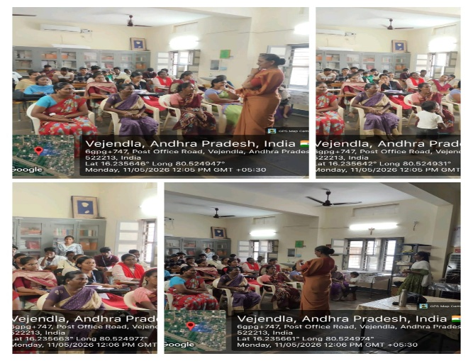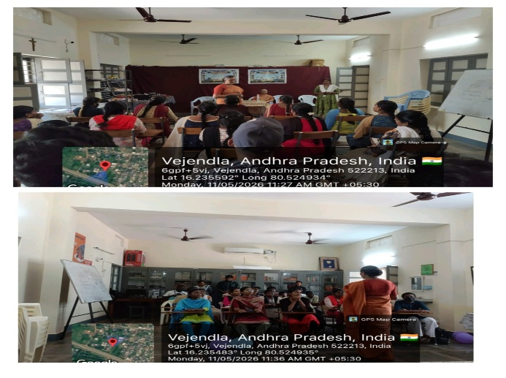

The event concluded successfully with active participation and positive interaction from both trainees and parents. The trainees expressed their happiness and gratitude towards DB Tech Vejendla for providing valuable training, guidance, and career opportunities.

The programme came to an end with a prayer, seeking blessings for the successful journey and bright future of all the trainees.

Thank you….

