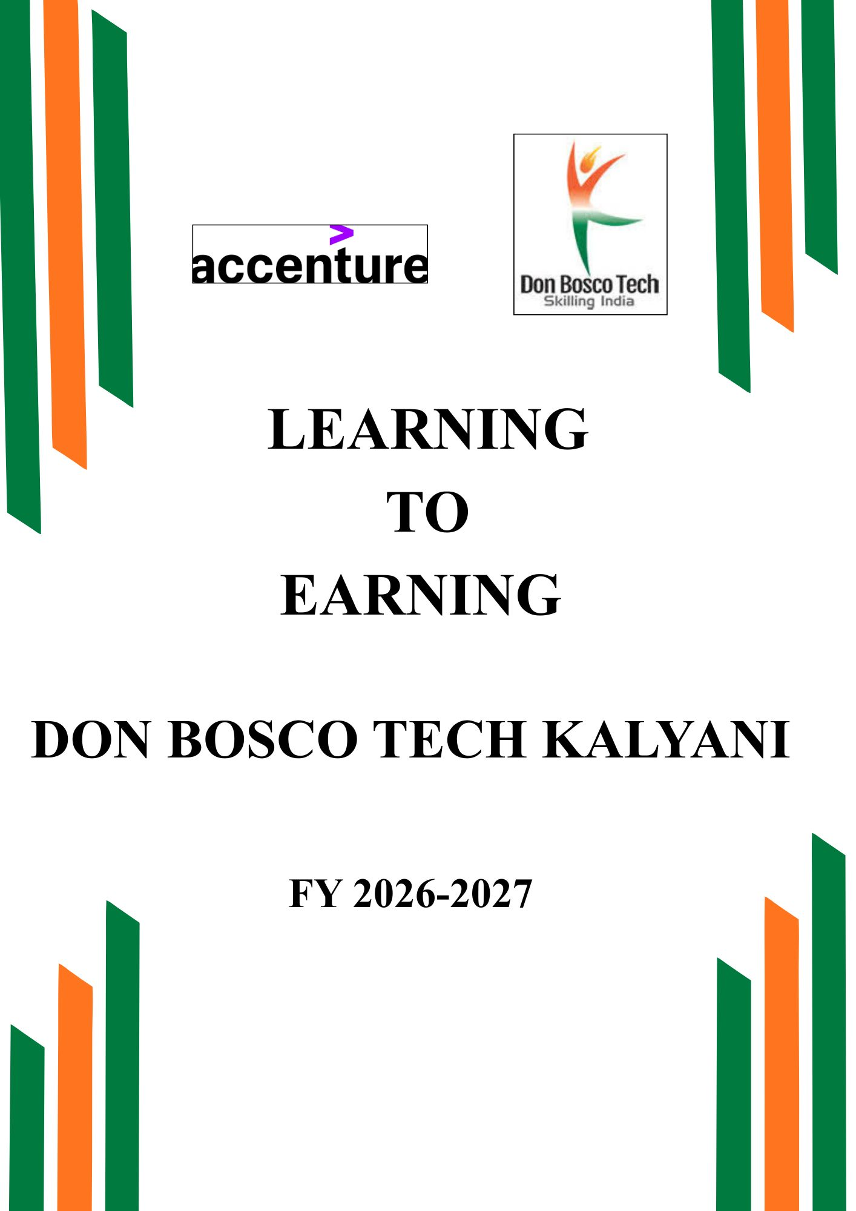
DON BOSCO TECH – KALYANI
BATCH INAUGURATION & 1ST PARENTS
TRAINER MEET B-1 (KITCHEN TRAINEE)
LEARNING TO EARNING YEAR 2026-27

Name of the Activity – Batch Inauguration & 1st Parents Trainer Meet
Date of the Activity – 11.05.2026
Guest Name – Fr. KT Thomas (Centre-In-Charge of Don Bosco Tech Kalyani),
Activity Photographs
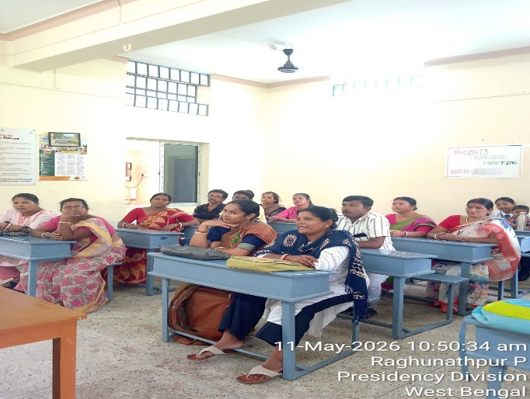
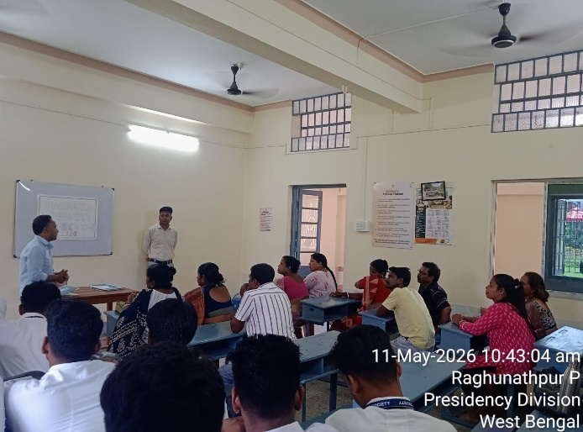

On 11th May 2026, during the first half of the day, Don Bosco Tech Society Kalyani organized an Inauguration and PTM program. The official time for the program was 10:00 AM; however, it started around 10:45 AM.
With the support of Fr. KT Thomas, the program began with the sharing of information about Don Bosco and the Don Bosco Tech Society. Later, we explained our course modules to the parents. Moreover, we spoke about the collaboration between Accenture and Don Bosco, along with the facilities and opportunities students can gain from it.
An interactive session was also held between the trainers and the parents, where various queries raised by the parents were answered by the trainers. Furthermore, practical insights regarding the Hospitality Industry were shared with the parents. In the end, the parents expressed that their doubts had been resolved and conveyed their gratitude to the Don Bosco Tech Society for providing such an opportunity.

