REPORT ON THE INNAUGURATION AND 10TH ANNIVERSARY CELEBRATION.
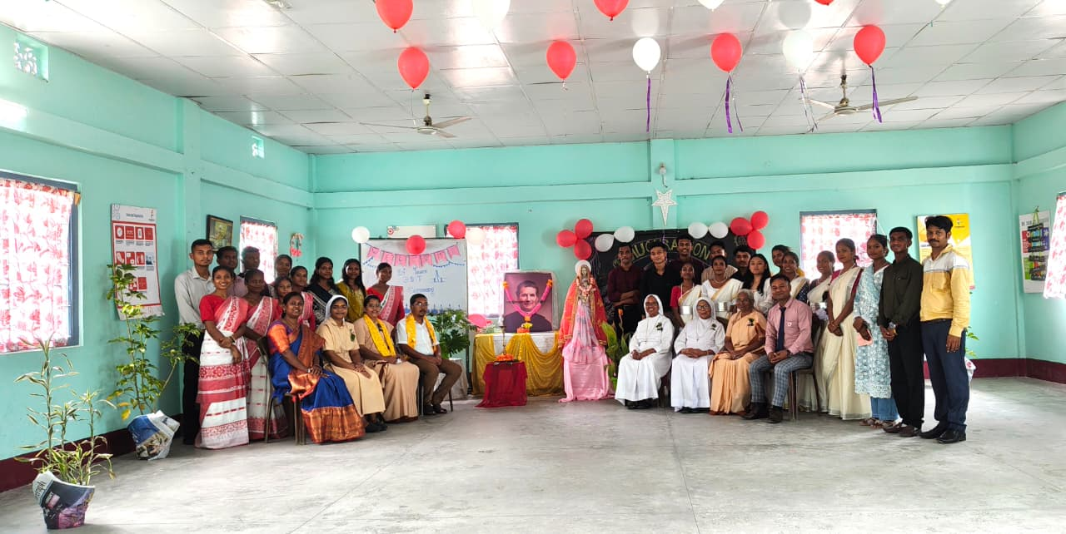
I

The celebration of Inauguration and 10th Anniversary of our Don Bosco Tech Latabari Centre was held on 10th June 2026 at Don Bosco Tech Latabari Centre’s Hall room. The event marked a significant milestone, celebrating a decade of achievements, growth, and service.
The program commenced with lighting of the ceremonial Lamp and the welcome song. Distinguished Chief Guest Mr. Karma Lama Govt. School Teacher and BLO of Kalchini Block, Respected Sisters, Staff Members, students and well by-wishers attended the event. The chief guest officially inaugurated the program and delivered speech highlighting the organization’s contributions over the past ten years.
A welcome address was delivered by the centre in charge- Sr. Viviana followed by the prayer dance. Cultural performances, including songs and dances, added color and enthusiasm to the celebration.
The event concluded with a vote of thanks expressing gratitude to the Chief Guest, all the sisters, participants, and everyone who contributed to the success of the celebration. The program ended on a joyful note with refreshments among the attendees.
Overall, the Inauguration and 10th Anniversary Celebration was a memorable occasion that reflected the organization’s achievements and inspired everyone to work towards brighter future.

