Don Bosco Skill Mission-DBSM
Don Bosco Tech Society

2127/81/2d/1, Don Bosco Skill Mission, Kothanur Road, Bengaluru, Karnataka 560076

Success story of monaliza dkhar sawian

CANDIDATE DETAILS

PARTICULARS | DETAILS | PHOTOGRAP H
Project* | Learning to Earning 2026-27 | 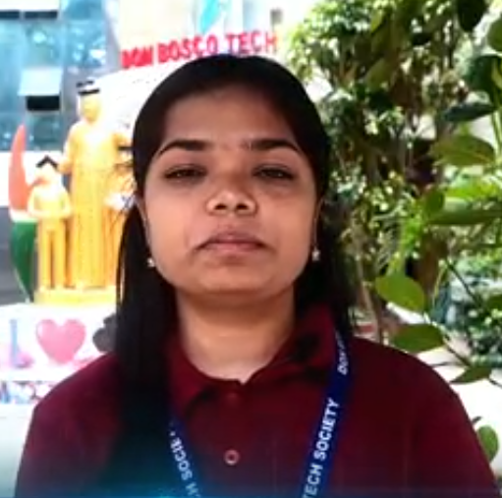
State | Karnataka
Training Center | Don Bosco Skill Mission (DBSM)
Candidate ID | 260186004
Name of the Candidate* | R Kaviyadharshini
Gender (Male/Female)* | Female
Mobile No. | +91 8837315023
Category  (General/SC/SCT/OBC/PH/O thers) | OBC
Religion | Hindu
Domain* | AWS Cloud Practitionar(B5)
Batch Code | 2601860 (B5)

Name of the Training Partner | Don Bosco Skill Mission (DBSM)

OTHER DETAILS

EMPLOYMENT DETAILS
Sl.No. | Particulars | Details
1 | Designation of Trainee | Growth Specialist
2 | Name of the Employer* | R Kaviyadharshini
3 | Address of the Employer*
4 | State(Employer) | Tamilnadu
5 | District(Employer) | Dindigul
6 | Monthly Salary Offered by

 | Employer*
CANDIDATE DETAILS
1 | Complete Address of the Candidate* | 9-3-10 anbunagar vadipatti SEVUGAMPATTI Dindigul Tamil Nadu - 624211 8124980252
2 | State | Tamilnadu
3 | District | Dindigul
4 | Education Qualification | 12th Standard
5 | The sector of the Training Completed | Don Bosco Skill Mission (DBSM)

A Spark Ignited: From Village Dreams to IT Industry

Name: R Kaviyadharshini, Sevugampatti, Dindigul, Tamil Nadu – 624211Course: AWS Cloud Practitioner (Registration No: 260186004)
R Kaviyadharshini enrolled in the AWS Cloud Practitioner course (Reg. No. 260186004) under the Learning to Earning 2026–27 project at Don Bosco Skill Mission, Bangalore. Driven by a strong desire to build a stable career and improve her employability, she actively participated in the training and made the most of every learning opportunity.
During the program, Kaviyadharshini gained strong technical knowledge, developed excellent communication skills, and built essential professional capabilities. She enhanced her workplace readiness, built confidence, strengthened her professionalism, and recognized the importance of teamwork, discipline, and problem-solving. The training thoroughly prepared her to meet industry expectations and equipped her with the confidence needed to launch her career in technology.
Following the successful completion of the program, Kaviyadharshini secured a role in the IT industry at Growth Specialist in Primevector in Bangalore, earning a monthly salary of ₹20,000+. This achievement marks a significant milestone in her professional journey and serves as her first step toward financial independence.
Kaviyadharshini’s journey reflects how targeted skill training, proper guidance, and individual determination can transform aspirations into meaningful employment. She expresses her heartfelt gratitude to Don Bosco Skill Mission for equipping her with the skills, knowledge, and confidence needed to embark on a successful career path. Her story serves as an inspiration to other young individuals striving for a brighter future through skill development and dedication.

Thank You.

